

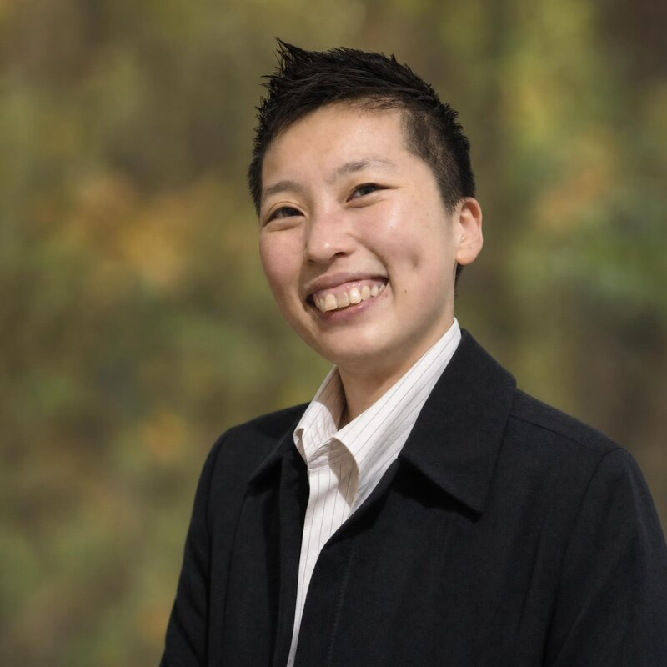  Dr. Jasmine Low  Organisational Psychologist & Systems Coach  CONTACT  Team  BHD Asia  Based  Singapore  E-mail  isabelle@bhdasia.com  Web  bhdasia.com  CORE SKILLS  ▪ ORSC Systems Coaching  ▪ Leadership & Team Development  ▪ Organisation Development & Change  ▪ Psychological Safety  ▪ Strategic Planning & Change  ▪ Experiential Learning  ▪ Process Facilitation  ▪ Design Thinking  ▪ Data Analysis & Research  LANGUAGES  ▪ English  ▪ Chinese  ▪ Spanish | "Helping leaders and teams navigate complexity, build alignment, and strengthen psychological safety."  Profile  Part of the BHD Asia team, Dr. Jasmine Low is an Organisational Psychologist with over 15 years of experience designing and delivering interventions that drive leadership development, organisational transformation, and team effectiveness. She blends evidence-based psychology with systems thinking and human-centered design.  As a systems coach and facilitator, Jasmine helps leaders and teams navigate complexity, build alignment, and strengthen psychological safety. Her calm, adaptive presence fosters reflective and inclusive spaces for growth. To date she has supported over 100 organisations across healthcare, education, government, and technology.  Selected Engagements  • Manager as Coach Programme — As a faculty member of KOSS Associates (USA), delivered coaching-skills programmes strengthening reflection and leadership presence for senior and mid-level leaders. Clients: Xylem International, Woodlands Health, Singapore Sports School.  • Culture Building, Woodlands Health — Engaged as Adjunct Facilitator for an organisation-wide culture initiative covering psychological safety, values alignment, communication dynamics and speech acts.  • Psychological Safety & Team Development — Designed and facilitated ORSC-based team programmes to strengthen group cohesion and surface team dynamics. Clients: Thermo Fisher Scientific, Ngee Ann Polytechnic, Woodlands Health.  • Strategy, Change & Systems Thinking — Facilitated strategic meetings, leadership programmes and change initiatives using systems constellations and ORSC methods. Clients: NUHS, SG Enable, MSF, Singapore Polytechnic, Mitsubishi Electric.  • Community Building & Complexity — As faculty of AND Pte Ltd, facilitated Civic Trails and reflective dialogues that help teams navigate diversity and systemic resilience. Clients: DBS, OCBC, CSC, MOE, Millennia Institute.  • Capability Building — Delivered facilitation and design-thinking workshops that build internal capability. Clients: Association of Singapore Teachers, various MOE clusters.  Education  Ph.D. in Human Resource Psychology (Cum Laude & International Mention) 2015–2019  Universidad de Valencia, Spain  Erasmus Mundus Master — Work, Organizational & Personnel Psychology 2012–2014  Universidad de Valencia & Università di Bologna  B.A. in Psychology (Org. Psychology & Marketing minors) 2008–2011  Murdoch University, Australia  Certifications & Professional Development  • Organization & Relationship Systems Coaching (ORSC) — CRR Global (2022)  • Advanced Certificate in Learning & Performance (ACLP) — Institute of Adult Learning (2020)  • Design Thinking Facilitator — Design Thinking Academy (2020)  • Organisational Development & Change; Self & System — AND Pte Ltd (2022–2024)  • Certified People Developer — SPRING Singapore (2004); DISC Consultant (2011)  Recognition  • "Young Organizational Psychologist with Talent" — Colegio Oficial de Psicólogos de Madrid (2016)  • Erasmus Mundus Scholarship — European Commission  • FPU Research & Teaching Scholarship — Ministry of Science, Spain  Community Leadership  • Board Member — Singapore Traditional Wushu Federation (2025–Present)  • Treasurer — School Advisory Committee, Huamin Primary School (2022–Present)

